|  |  |  |  |
| --- | --- | --- | --- |
| **Name of Student: NINAD AVINASH PATIL** | | | |
| **Roll No: 33** | | **Lab Practical Number: 1.2** | |
| **Title of Lab Practical: WAP in C# to design a simple calculator using Window Form.** | | | |
| **DOP: 10/02/2021** | | **DOS: 15/02/2021** | |
| **CO Mapped: CO1** | **PO Mapped: PO3, PO5, PO7,**  **PO12, PSO1, PSO2** | **Faculty Signature:** | **Marks:** |

**Practical No 1.2**

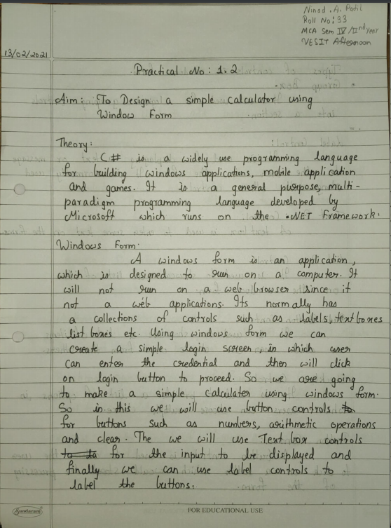

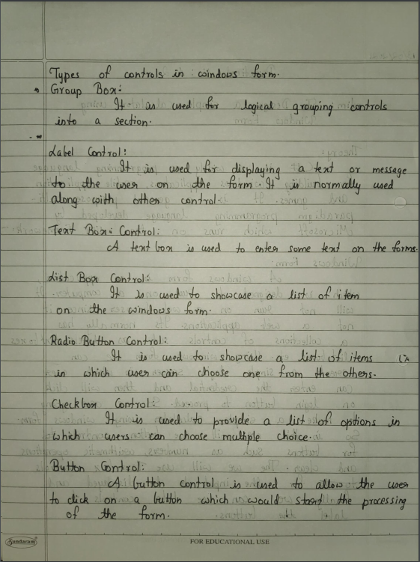

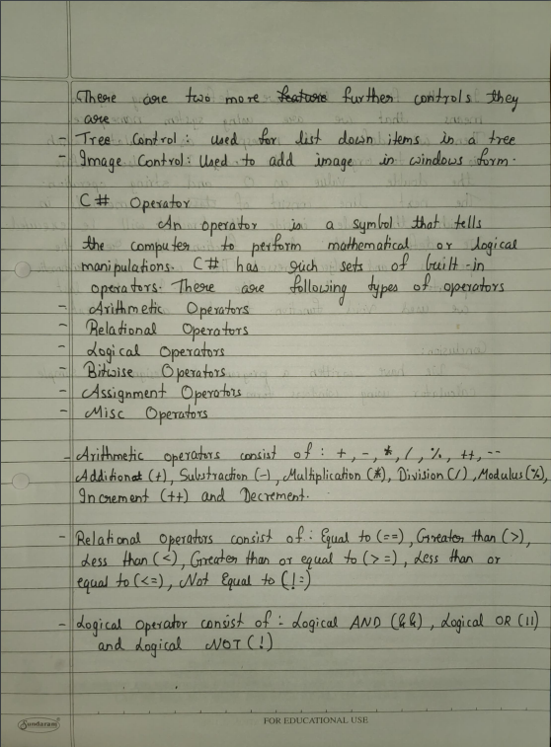

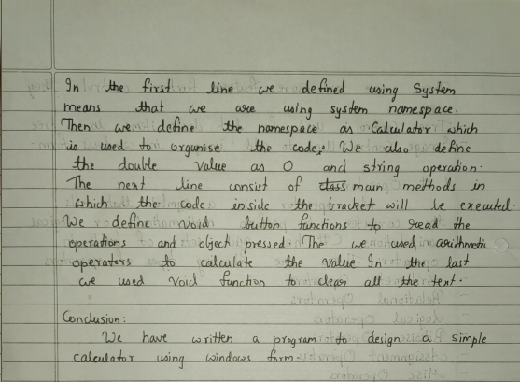

**Code:**

using System;

using System.Collections.Generic;

using System.ComponentModel;

using System.Data;

using System.Drawing;

using System.Linq;

using System.Text;

using System.Windows.Forms;

namespace Calculator

{

public partial class Form1 : Form

{

Double n, n1;

string output;

public Form1()

{

InitializeComponent();

}

private void Form1_Load(object sender, EventArgs e)

{

}

private void textBox1_TextChanged(object sender, EventArgs e)

{

}

private void button1_Click(object sender, EventArgs e)

{

textBox1.Text = textBox1.Text + button1.Text;

}

private void button2_Click(object sender, EventArgs e)

{

textBox1.Text = textBox1.Text + button2.Text;

}

private void button3_Click(object sender, EventArgs e)

{

textBox1.Text = textBox1.Text + button3.Text;

}

private void button5_Click(object sender, EventArgs e)

{

textBox1.Text = textBox1.Text + button5.Text;

}

private void button6_Click(object sender, EventArgs e)

{

textBox1.Text = textBox1.Text + button6.Text;

}

private void button7_Click(object sender, EventArgs e)

{

textBox1.Text = textBox1.Text + button7.Text;

}

private void button9_Click(object sender, EventArgs e)

{

textBox1.Text = textBox1.Text + button9.Text;

}

private void button10_Click(object sender, EventArgs e)

{

textBox1.Text = textBox1.Text + button10.Text;

}

private void button11_Click(object sender, EventArgs e)

{

textBox1.Text = textBox1.Text + button11.Text;

}

private void button13_Click(object sender, EventArgs e)

{

textBox1.Text = textBox1.Text + button13.Text;

}

private void button4_Click(object sender, EventArgs e)

{

n = Double.Parse(textBox1.Text);

textBox1.Text = " ";

output = "+";

}

private void button8_Click(object sender, EventArgs e)

{

n = Double.Parse(textBox1.Text);

textBox1.Text = "";

output = "-";

}

private void button12_Click(object sender, EventArgs e)

{

n = Double.Parse(textBox1.Text);

textBox1.Text = "";

output = "*";

}

private void button16_Click(object sender, EventArgs e)

{

n = Double.Parse(textBox1.Text);

textBox1.Text = "";

output = "/";

}

private void button14_Click(object sender, EventArgs e)

{

textBox1.Text = " ";

}

private void button15_Click(object sender, EventArgs e)

{

Double result;

n1=Convert.ToDouble(textBox1.Text);

if (output == "+")

{

result = (n + n1);

textBox1.Text = Convert.ToString(result);

n = result;

}

if (output == "-")

{

result = (n - n1);

textBox1.Text = Convert.ToString(result);

n = result;

}

if (output == "*")

{

result = (n * n1);

textBox1.Text = Convert.ToString(result);

n = result;

}

if (output == "/")

{

if (n == 0)

{

textBox1.Text = "No";

}

else

{

result = (n / n1);

textBox1.Text = Convert.ToString(result);

n = result;

}

}

}

private void button17_Click(object sender, EventArgs e)

{

textBox1.Text = textBox1.Text + button17.Text;

}

}

}

**Output:**

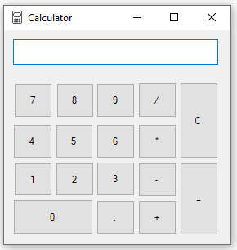

**Addition:**

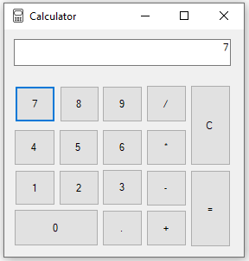 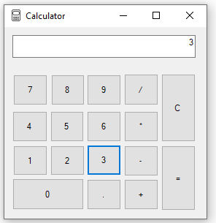 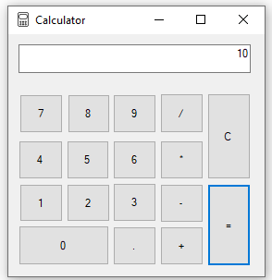

**Subtraction:**

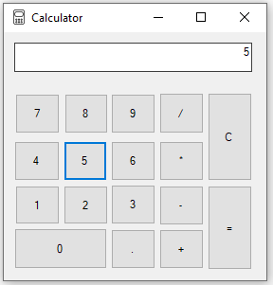 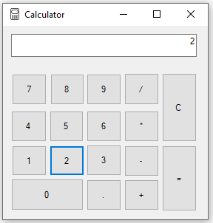 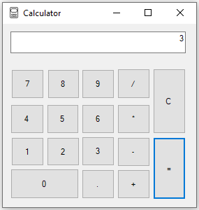

**Multiplication:**

